Unappreciative Inquiry

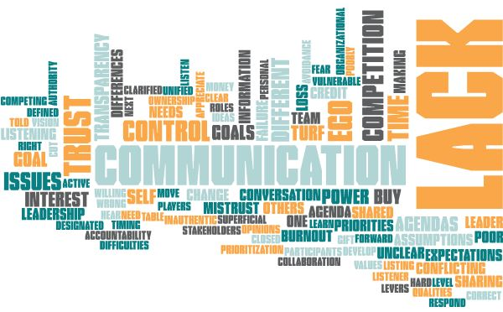
How to move ideas forward to the next level
Vulnerable willing to listing and learn
Appreciate the gift of failure
Superficial
Not the right players
Avoidance of hard conversation
Listening to others opinions
Fear of change
Closed to change
Lack of buy-in
No shared vision
Poorly defined roles
Inauthentic leadership
Competing agendas
Failure to develop the correct goal
No designated leader
Lack of buy in
Lack of ownership
Different values
Own agenda
Not active listener
Lack of leadership qualities
No clear leader
Lack of goals
Money
Personal agenda
Wrong stakeholders at table
Lack of accountability
Participants told what to do
Lack of organizational authority/power
Different needs
Need clarified, unified goal
Lack of communication
Listen to hear, not respond
Cut off from levers of power
Lack of time
Lack of prioritization of collaboration
Timing difficulties
Lack of time job life demands
Not enough time – gave up too soon or rushed the issue
Time
Communication breakdown
Poor communication
Making assumptions about priorities interests concerns
Miscommunication
Unintentional withholding of information
Lack of communication
Lack of communication
Poor communication
Lack of communication
Lack of ongoing communication
Shared expectations
Individual agendas
Hidden agendas
Different objectives priorities
Disrespect for others on team
Mistrust
Mistrust
Who takes credit
Trust issues
Conflicting outcomes
Lack of consensus
Misunderstanding of common goal unclear goals
Conflicting goals
Lack of transparency
Lack of respect loss
Not taking time to build trust
Lack of trust
Broken trust
Lack of transparency trust
Lack of transparency trust
Knowing one another cultural differences
Trust
Burnout
Power control issues
Capacity
Loss of control
Control
Funding issues
Lack of resources
Uneven distribution of credit unnecessary competition
Turf letting go of competition
Overlapping responsibilities loose turf
Competition
Competition
Competition
No flexibility
Lack of buy in
Branding
Misleading the team
Certain questions should not be asked early on in the conversation first misstep cannot be overcome
Ego
Incompatibility of communications technology
Generational differences in communication
Politicking
Lack of listening
Making assumptions
Lack of communication
Lack of communication
Unclear expectations
Sharing information in only one way
Assumption of knowledge
Institutional interest greater than group interest
Ego
Ego and pride
Ego
Self interest ego self preservation
Ego personality
Being more concerned about self image vs community needs
Different intentions
Disorganized
Turf issues territorial and not wanting to give up control or culture
Working in silos
Being possessive of work and not sharing
Control
Scarcity mindset
Fears
Burnout

