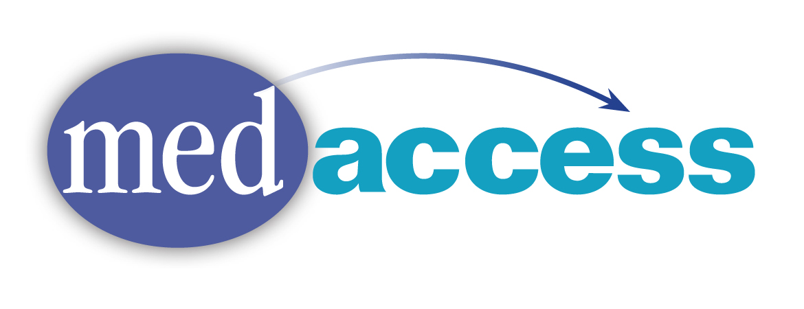

**Program Information:**

**Who can get help?**Anyone who needs help saving money on prescription medications.

**How does it work?**   
MedAccess staff will work with you to lower your medication costs through Prescription Assistance Applications and/or $4 generics.

**What is a Prescription Assistance Program?**   
Prescription Assistance Programs (PAPs) are free medication programs offered by the pharmaceutical companies for people who cannot afford their medications. We work with you and your doctor's office to complete the paperwork and follow up to make sure you're getting your medication. Medication is either sent to you or to your doctor, depending on each company’s rules.

**How much does MedAccess cost?**There is no charge to you or your doctor for our services.

**MedAccess does:**

* Assist patients by helping them apply for free medication through the Prescription Assistance Programs (PAPs) that exist through individual pharmaceutical companies
* Refer people to community resources such as; General Assistance and CarePartners
* Refer people to health insurance such as; MaineCare, Medicare, Health Insurance Marketplace or Veterans Benefits
* Price check medication at local pharmacies for the best price, as well as to see if there is a generic alternative

**MedAccess does not:**

* Have medications on hand; we do not have medication samples
* Guarantee that an application for medication will be approved or when the pharmaceutical company will send medications once approved.

**Things you need to be aware of:**

* It generally takes 4-6 weeks for the PAP to be processed and approved.
* Most companies send a 90 or 120 day supply of the medication to the patient’s home or doctor’s office.

**Who do I call?**   
We are a statewide program. You or your doctor can call us toll-free at 1-877-275-1787 or 207-662-7968.